Title of the work that will be presented at POLYMAR2018

N. Surnames ⁽¹⁾, N. Surnames ⁽²⁾, N. Surnames

⁽¹⁾ Principal Author Address.
Principal Author’s Phone Number and e-mail

⁽²⁾⁽³⁾ Remaining Authors address (if different to the principal author’s address).

- Introduction – the main objectives, results and findings of the work that will be presented at POLYMAR2018 which will be published in the book of abstracts. It must be limited to one A4 page, and the margins must be 20 mm on the left and 25 mm on the right. Please the format of this template to prepare your abstract.
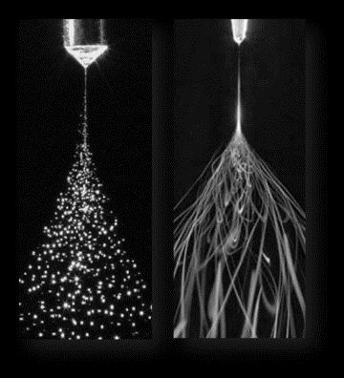
Image 1. Description

- Experimental - If necessary, use this dedicated section for the experimental part, and describe briefly the means used.

- Results and Discussion - The results can be presented and discussed including, if necessary, tables and images. The tables will be referred using table+Roman numerals (e.g.Table I) and the images, using Image+order number (e.g. Image 1).

Table I. Description
Variable 1 | Variable 2

- Conclusions - Summarize the main conclusions of the work and relevant contributions to the field.

- References
[1]. Lagaron, J.M. et. al., Nanotechnology for bioplastics: Opportunities, challenges and strategies. Trends in Food Science and Technology, 2011. 22(11): p. 611-617.

